Preoperative Skin Wash
Your role in helping to prevent a surgical site infection
You can reduce the amount of bacteria on your skin by carefully washing with a special soap called Chlorhexidine Gluconate (CHG).
- A common brand name for this soap is Hibiclens, but any brand of CHG is acceptable to use available in 8 oz bottles from your local drug store or Amazon
- If you have sensitive skin, you may use Dial Antibacterial soap instead of CHG.
- Following these instructions will help ensure that your skin is clean before surgery
- Do Not use CHG if you are allergic to chlorhexidine, use Dial instead
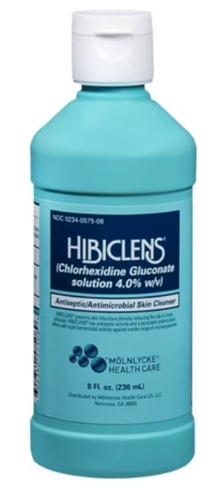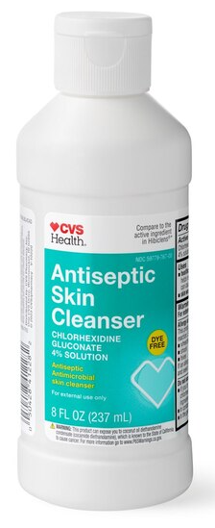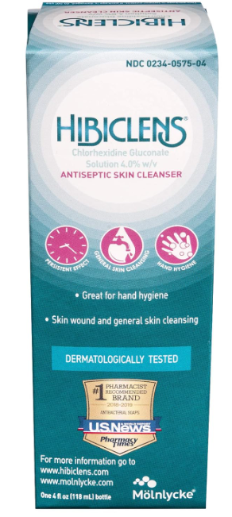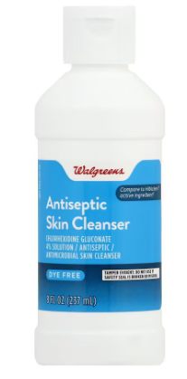
When to shower with the CHG solution
For five days prior to surgery:
- Remove all jewelry (jewelry must remain off until after surgery)
- Take a shower with your normal soap, shampoo, & conditioner
- Rinse off your normal soap products & turn off the water
- Using a clean, wet washcloth, pour some Hibiclens onto the cloth and scrub gently at the area of surgery first for 3-5 seconds. Then wash from your neck down.
- Leave the Hibiclens soap on for 5 minutes
- Rinse off and dry off with a clean towel
The Morning of Surgery
- Do not shower the morning of your surgery, we will be doing a final skin prep when you arrive
- Wear clean and comfortable clothes to the surgery center
- Nail polish from at least one finger on each hand must be removed prior to surgery

